

BIT 4107 – Mobile Application Development
ENHANCED PROFESSIONAL STUDENT LOGBOOK
Student Name: SHEILA WAITHERA MURIITHI
Admission Number: BIT/2024/32455
Academic Year: YEAR 4
Semester:SEM II
Lecturer:Mr.Nyoro

Table of Contents
Week 4 Assignment 3
Create data 3
Editing data 4
Deleting data 4
Tool used: 5
Personal Reflection; 5

Week 4 Assignment
CRUD Operations
Create – Insert data.
Read – Retrieve data.
Update – Modify data.
Delete – Remove data.

Create data

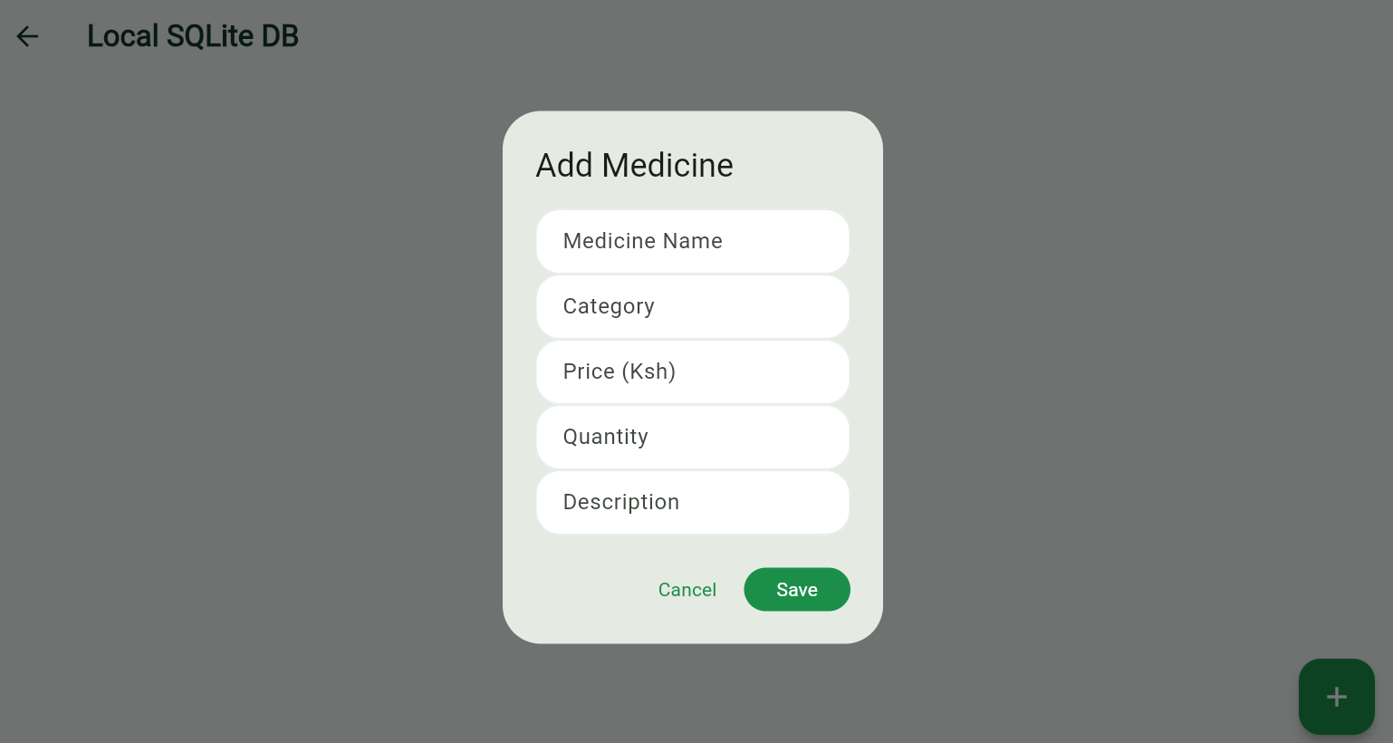

Editing data
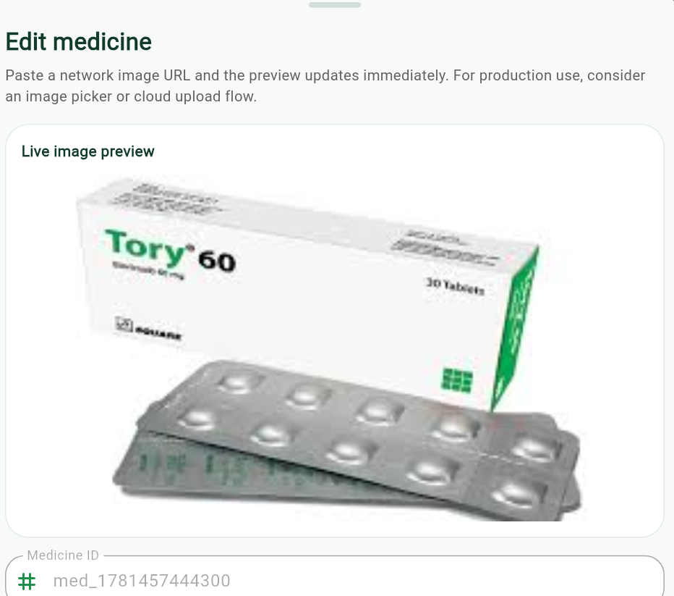

Deleting data
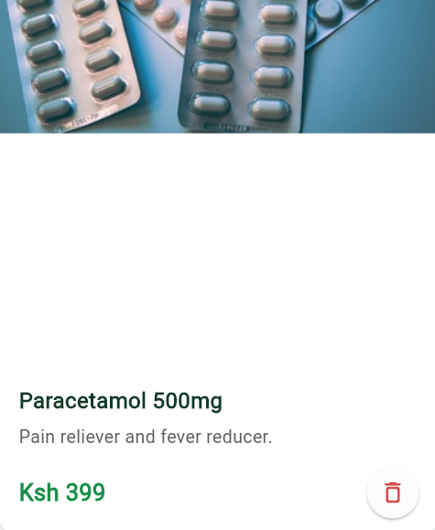

Tool used:
Flutter, Dart, SQLite (sqflite for local database), and shared_preferences (for local state).

Personal Reflection;
Building this local CRUD system highlights the power of offline-first architecture. Combining SQLite with reactive Streams ensures the UI remains fast and perfectly synchronized with the database, creating a seamless and reliable user experience.

